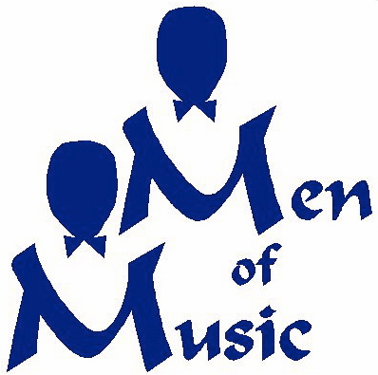 Scholarship

The Men of Music Scholarship is an endowed scholarship within the “Art from the Heart” scholarships administered by the Midland Center for the Arts.

Mission and Purpose
The mission of the MoM scholarship is to provide funding for vocal music instruction and vocal music camps to males entering 7th through 12th grade. In keeping with the membership of the MoM choral group, students in Midland, Bay, and Saginaw Counties are eligible for this scholarship. The selection of recipient students will be based on academics, school and community involvement, and vocal music performance experience.

A scholarship committee established by the MCFTA with representatives from MCFTA and the Men of Music will recommend one or more students to receive the award each year. The award is an annual reward that does not automatically renew. Applicants may reapply each year for the award.
Award checks will be issued to the music camp or vocal instructor designated by the applicant. If the scholarship winner has already paid for this activity, a check will be issued to the applicant upon submission of proof of payment. Award winners may be asked to take part in a Men of Music performance. Such participation is encouraged but not required.

We will award at least one $250.00 scholarship. It is possible that more than one scholarship would be awarded.

Men of Music Scholarship
Application
(Draft)
Applicants full name _______________________________________________
Name of school and grade
Home Address

Phone number
Email
Please attach report cards or transcripts for last two semesters of school. These can be photocopies.
How will the scholarship be used:

Vocal music camp
Attach evidence of acceptance to camp, the name and address to which
Which payment must be remitted, and the payment due date.

Private vocal music instruction
Attach letter from vocal music instructor including costs of lessons
how long you have been taking lessons, and the name and address
to which payment must be submitted.
Other vocal music activities:
Describe:

Description of community involvement activities and school extracurriculars

Music background
Tell us about any musical performance experiences you have had:

Tell us about any music groups you are or have been a member of:

Why are you applying for this scholarship and how will it benefit you?

Please attach two letters of recommendation from people who are familiar with your vocal music involvement. This could be choral directors, music instructors, church choir directors, etc.
Applications must be completed by May 1st, 2015
Awards will be announced by June 1st, 2015

_________________________________________ __________________
Signature Date

