Welcome to the

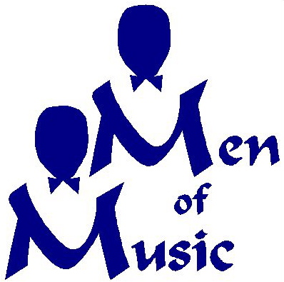

August 29, 2015
Welcome to the Men of Music
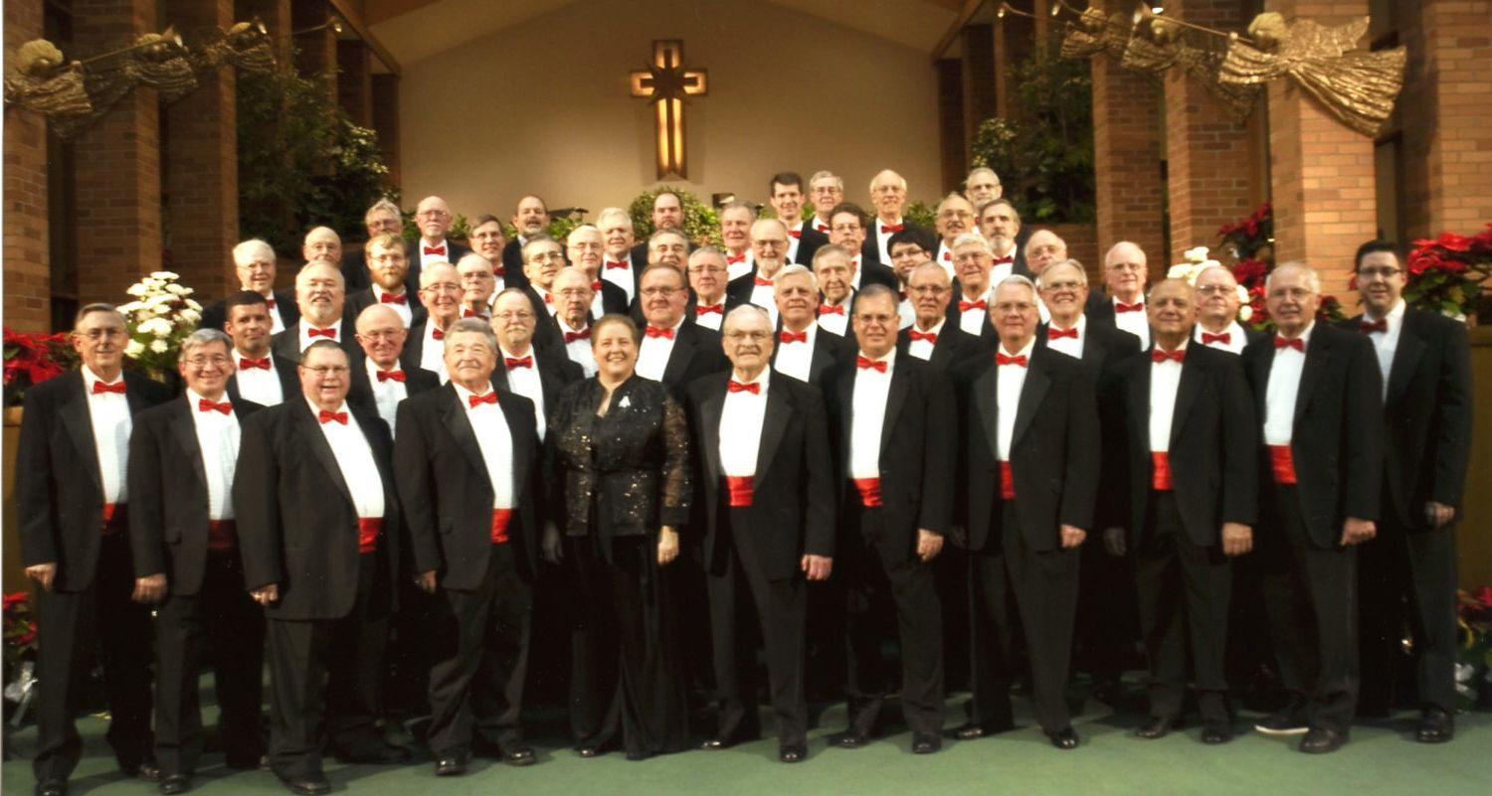

Our History
The Men of Music (MOM) is one of Michigan’s best men’s choral groups. Founded in 1936 in Midland, Michigan, as the Dow Male Chorus, it was part of the Dow Music Department until it was discontinued in 1961. Renamed the Men of Music, it was an independent group until 1973, when it joined the former Music Society, now known as Center Stage Choirs of Midland Center for the arts.
Over the years the Men of Music has had several fine conductors. Grace Marra has been our director since January 1995 and our accompanist is Theresa Wasinski. More information about the Men of Music can be obtained from our web site at www.menofmusic.org.

Our Purpose and Schedule
Our overall purpose is to bring men’s four-part harmony music to the people of the tri-cities area. This takes the form of popular, religious, barbershop and time-honored songs from all generations.
Our two yearly productions include benefit Christmas concerts at local churches in December, and Spring Shows that are performed in the Little Theater of Midland Center for the Arts. In addition, we perform at MCFTA concerts, at local retirement facilities, service clubs, churches and many other functions.
Becoming a member is as simple as having a desire to sing in a choral group. No auditions are required, but singing for the director is needed to assist in appropriate section placement.
Members are expected to attend all rehearsals, most of which are on Tuesday evenings from 7:30 pm to 10:00 pm. Members who miss more than four rehearsals in any half-year period may not be permitted to participate in the upcoming concert or show at the conductor’s discretion.
Music is not used during performances. To aid in memorization, a part specific recording of the songs is made available to each member to practice at home. Many of the songs that must be memorized during a typical year have been sung in recent years; therefore, memorization becomes easier after a member has been in the chorus for a few years.
Members pay a yearly membership fee of $45. Each member then receives music, a tuxedo with shirt, tie and cummerbund, and a sport coat with tie and pants at no cost. If a member leaves the chorus, all these items must be returned.

Rehearsals and Contact Information
Our rehearsals take place in Midland Center for the Arts (MCFTA) at 1801 W. St. Andrews Road, Midland, MI. Exceptions are indicated on the rehearsal schedule. The rehearsal rooms in MCFTA are accessed from the doors at the rear of the main parking lot closest to the Dow Gardens. Take the stairs or elevator to the basement.
If you are interested in becoming a member of this chorus, please contact our director, Grace Marra, at 989.631.1152.

